**The Nichols Cube Puzzle:**

Dr. Larry D. Nichols has studied chemistry on DePauw University in Greencastle, Indiana, before moving to Massachusetts to attend Harvard Graduate School.

He is a lifelong puzzle enthusiast and inventor there in 1957 began developing a twist cube puzzle with six colored face. It was made of eight smaller cubes there was assembled to a 2x2x2 cube the eight cubes was held together by Magnets. 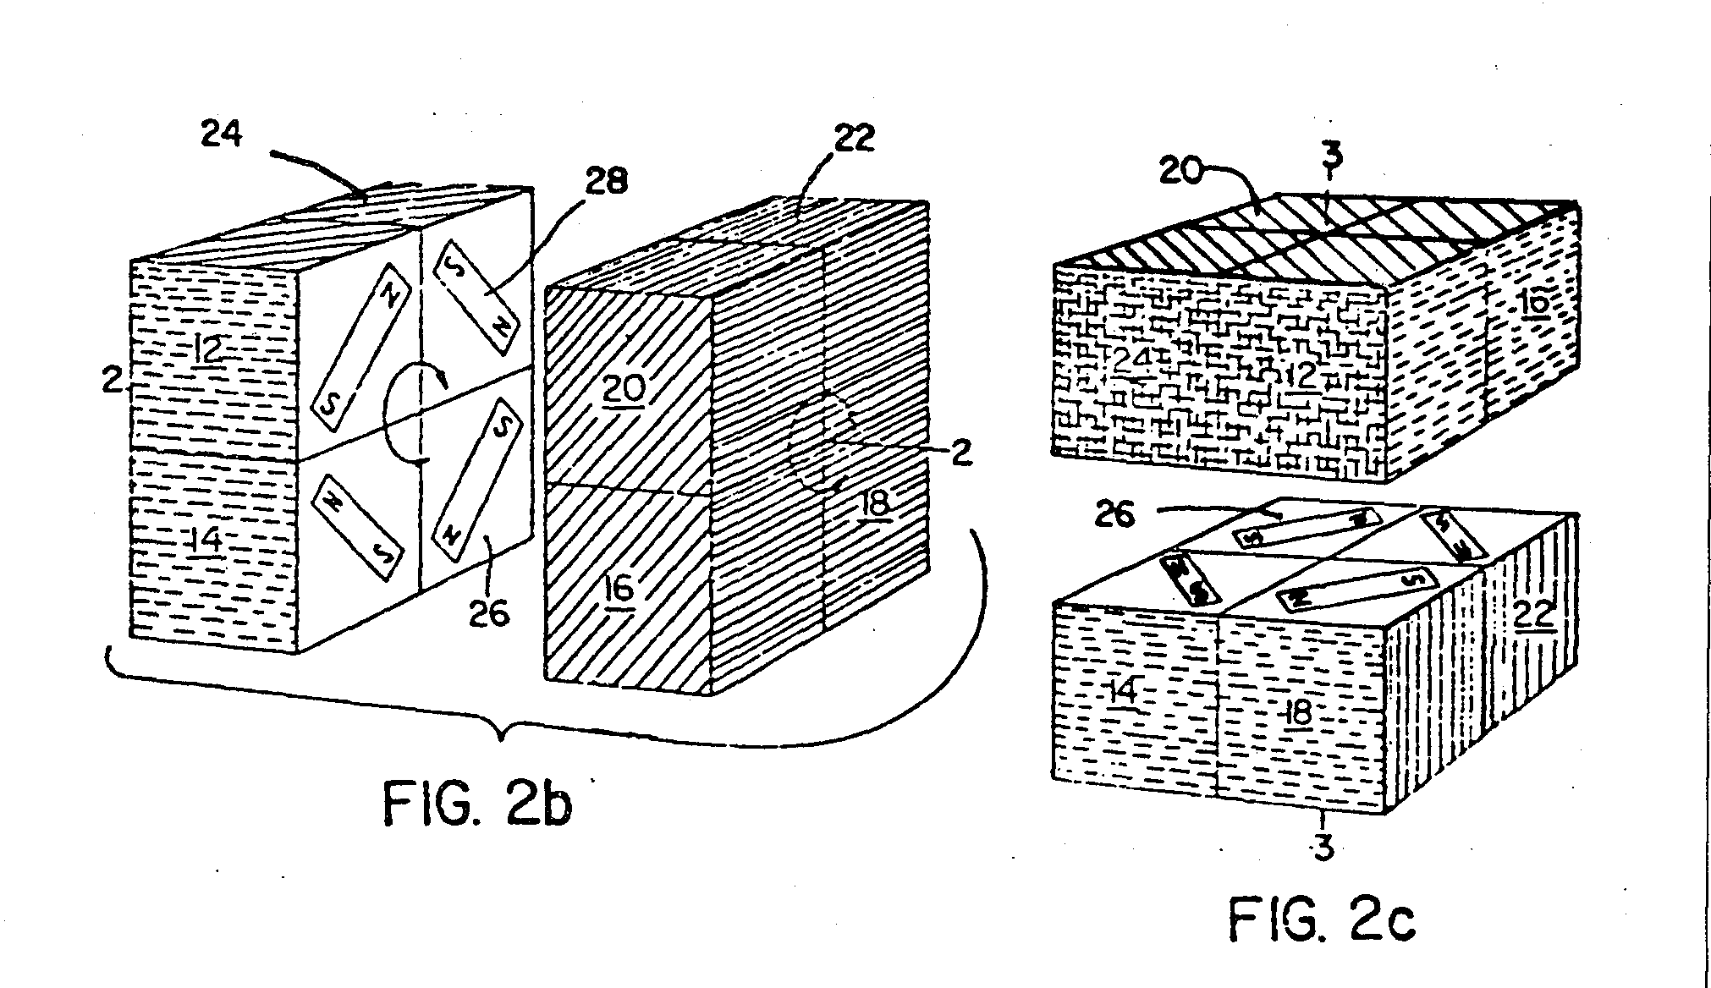

On April 11 1972 he on behalf of Moleculon Research Corp. Was granted [U.S. Patent 3,655,201](http://www.google.com/patents?vid=3655201) there was covering Nichols Cube and possibility for making larger versions later. This was two years before Ernő Rubik made patent for his Rubik’s Cube.

In 1982 Moleculon Research corp. Sued Ideal Toy Company there had the [U.S. Patent 4,378,116](http://www.google.com/patents?vid=4378116) for Rubik’s Cube because they mend that Ideal had broken there’s patent but the U.S. District Court ruled that Rubik’s Cube hadn’t broken Nichols patent but again in 1986 the Court of Appeals ruled that the Rubik’s Pocket Cubes 2x2x2 was guilty of infringement, but not the 3x3x3 Rubik’s Cube.

Kilder:

<http://www.ageofpuzzles.com/Masters/LarryDNichols/LarryDNichols.htm>

<http://digital-law-online.info/cases/229PQ805.htm>

<http://www.google.com/patents?id=Gk85AAAAEBAJ&printsec=drawing&zoom=4#v=onepage&q=&f=false>